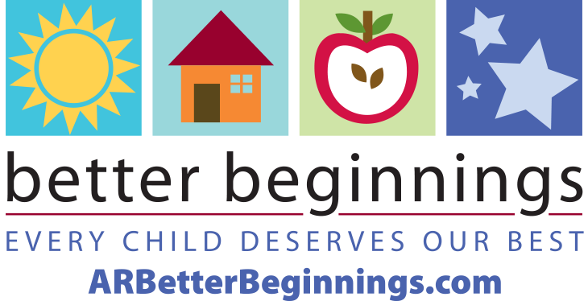
Letter to Parents Template

Date:

Dear Family,

We are excited to announce that we have earned our __-star rating as an Arkansas Better Beginnings program. Better Beginnings is Arkansas’s quality rating and improvement system for licensed child care and early childhood education programs.
Better Beginnings star-ratings signify the level of quality of child care for all Arkansas licensed child care providers. Better Beginnings providers reach and maintain star levels through continuous training and program improvements.
Some of the improvements we’ve made to earn our star rating include:
- Increased qualifications and training for staff and administrators
- Increased standards for classroom quality
- Daily activities that address learning goals for children
- Written curriculum plans.
“Research shows that maximum brain development happens during the first five years of life – before children are ‘officially’ in school. We want children to have the best start possible and the opportunity to start kindergarten with a solid foundation from which to continue their education,” said Tonya Williams, Director of the Division of Child Care and Early Childhood Education. Better Beginnings early childhood educators prepare children for kindergarten with positive experiences, research-based curriculum, and learning through play.
We invite you to visit ARBetterBeginnings.com to:
- Discover opportunities for learning through play at home in the Family Resource Library, located under the Parents and Families tab and Biblioteca de Recursos, under the Spanish tab.
- Have an interactive experience with the Play is Learning Parent Tool
- Sign up for the monthly newsletter, The Buzz for Families, to receive timely resources, tips and learning through play activities as well as news your family can use.
We are your partners in preparing your child for kindergarten and success in their future. Our goal is to provide the very best child care and early education as possible.

Sincerely,
(Program Director Signature)

