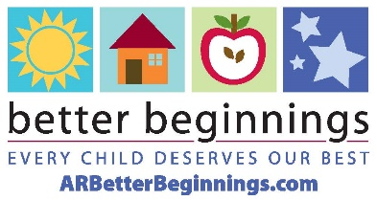

🌟 We’re thrilled to announce that **[Facility Name]** has earned a **Better Beginnings [#]-Star Level**! 🎉 This achievement reflects our commitment to providing the highest quality child care for families in **[City]**. A big thank you to our amazing team for their hard work and dedication!

#BetterBeginnings #QualityChildCare #EarlyChildhoodEducation #ChildCareMatters #ArkansasEducation #ArkansasChildCare