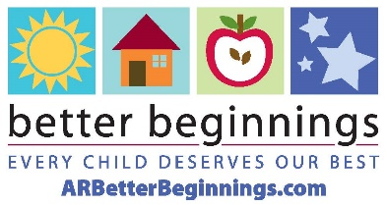

Media Contact:
[CONTACT NAME]
[PHONE NUMBER]
[EMAIL ADDRESS]

[FACILITY NAME] EARNS BETTER BEGINNINGS STAR LEVEL [#]

[Place your photo here, or just send it as an attachment]

[PHOTO CAPTION]

[CITY], Ark. (MON D, YEAR) – [Facility] announces the achievement of [#] Better Beginnings star level. This achievement showcases the staff’s commitment to providing high-quality child care to children and families in [city] and was accomplished after many hours of professional development by facility staff.

“[QUOTE],” said [DIRECTOR’S NAME, TITLE].

Better Beginnings is a program of the Arkansas Department of Education Office of Early Childhood focused on giving children the best quality care. The program gives child care providers a star rating, indicating the facility’s quality level. Access to high-quality child care brings economic benefits to communities. It helps working parents be more productive at work and fosters economic development.

“Better Beginnings providers enable the children in their care to be their best selves and discover their highest potential,” said Better Beginnings Program Administrator Kelli Hilburn. “Providers like [facility name] are great partners in our mission to ensure all children in Arkansas have the highest-quality care possible.”

To learn more about [facility name] and how they serve the community, find them on [Facebook/Instagram/Twitter] or check out their website at [website URL].

To learn more about the star levels or Better Beginnings, follow their social media channels on Facebook, Instagram, and Twitter, or visit arbetterbeginnings.com. Sign up for the Better Beginnings Buzz to receive monthly updates in your inbox.

###

About Arkansas Better Beginnings:
Better Beginnings is Arkansas’s tiered quality rating and improvement system for child care, early education and school-age programs that have gone above and beyond the state minimum requirements. Better Beginnings is administered by the Arkansas Department of Education Office of Early Childhood. Better Beginnings connects Arkansas families with the information and care that helps children experience a safe, happy and healthy childhood.

