[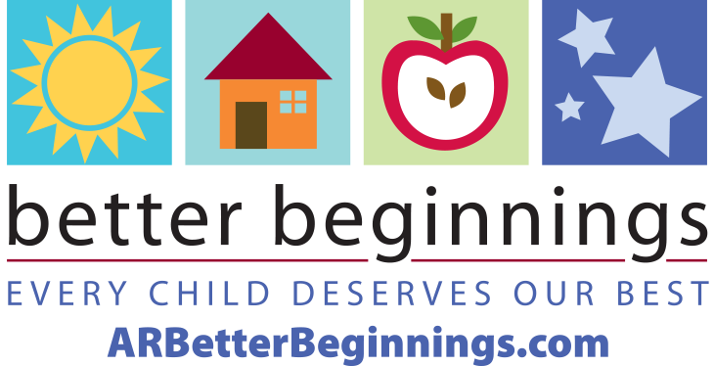](https://arbetterbeginnings.com/)**How to Use the   
Better Beginnings   
Star Kit**

Dear Program Administrator,

Congratulations on gaining your new Better Beginnings star level! Thank you for striving for the highest quality of care through Better Beginnings. This Star Kit provides the tools you need to let current and potential client-families, and your community, know about your impressive accomplishment.

To assist you on your journey with Better Beginnings, we invite you to follow us on Facebook, Twitter, Pinterest and Instagram, and stay caught up on Better Beginnings updates, with our monthly newsletter, *The Buzz for Providers.* You can sign up [here.](https://visitor.constantcontact.com/manage/optin/ea?v=0010YFcABXlzqUUSr2rdueJVEBA0AWSHqzomgvck7kQdUGrvC-vfrLw81GDTcdzobYX1IaSQj-Dxubck6E2KshOPA%3D%3D)

# Visit our website at [ARBetterBeginnings.com](https://arbetterbeginnings.com/) for resources to engage and educate client-families in [The Family Resource Library](https://arbetterbeginnings.com/parents-families/family-resource-library), located under the Parents and Families tab and [Biblioteca de Recursos](https://arbetterbeginnings.com/espanol/biblioteca-de-recursos), under the Spanish tab. You are free to download resource pages and reprint them to use as posters in your program or as handouts, email them to families or share them on your social channels.

# Reach for the Stars

Find the Application Checklists for every level of your type of child care program in one location: <https://arbetterbeginnings.com/providers-teachers/provider-tools/application-checklists> at [ARBetterBeginnings.com](https://arbetterbeginnings.com/).

**Press Release Templates**

Replace the highlighted text in the templates provided with your program information, then copy and paste the information onto your letterhead.

Let your community know about your program’s new star rating using the Star Kit *New Star Rating Press Release.* Replace the highlighted text with your information, then copy and paste the information onto your letterhead. Submit the release to your local newspaper and any other organization that might share your news in their social media or newsletters.Utilize the *Summer Child Care Press Release* in Spring to remind parents to make summer care arrangements early.

See *How to Finish and Distribute the News Release* for additional details on getting in print.

**Letter to Families Template**

Use this letter to tell client-families about the high-quality standards they will see because of the improvements made to your program to achieve your new Arkansas Better Beginnings certified child care provider star rating.

We encourage you to put this letter in your children’s back packs, post the news in your family newsletter, or on your social media channels and website. Be sure to use your program star level badge in all your correspondence and communications.

**Star Level Badges**

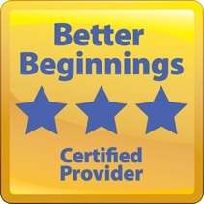 Star level badges like these are available for each star level. Simply download them from the Star Kit.

We recommend you use your full-color star level badge in your program’s print and social media. The one-color badge can be used for newspaper ads, flyers or for single-color premium items.

**Fact Sheet**

The Fact Sheet will be your go-to guide for answering questions about Better Beginnings. Use the guide when speaking with client- and potential-client families and to educate your community. Feel free to share the *Fact Sheet* pdf with others and direct them to [ARBetterBeginnings.com](https://arbetterbeginnings.com/)for more information about early childhood education and learning though play on our website.

**Logo Sheet**

As a Better Beginnings program, you have earned the right to use the Better Beginnings logo proudly. You will find a variety of Better Beginnings logos in the Star Kit for both print and online use. You are free to include the Better Beginnings logo and your program star level badge on all correspondence and media.

If you have questions about the materials in the Star Kit or would like more information, please contact us at **1-501-320-6161.**