[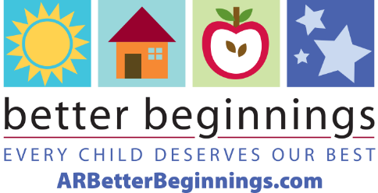](https://arbetterbeginnings.com/)

**Better Beginnings**

**2024 Fact Sheet**

***What is Better Beginnings?***

Better Beginnings, a program of the Arkansas Department of Education Office of Early Childhood, connects Arkansas families with early care and education providers that help their children experience a safe, happy, and healthy childhood in a high-quality learning environment. Better Beginnings also provides education for families and Arkansas early care and education providers with valuable tools for improving the quality of their programs at every level.

***What is the purpose of Better Beginnings?***

Better Beginnings is designed to improve the level of quality in early care and education programs across the state. Better Beginnings distinguishes the quality of each Arkansas early care and education facility by a star rating system of levels 1 through 6. More stars mean higher quality care.

***How is a program rated for its quality of care?***

Better Beginnings works with providers to train their staff and build a high-quality learning environment. Rating requirements include education and professional development for the director administrator and teachers, assessment of the learning environment, curriculum, and activities for learning through play.

***How does Better Beginnings assist with finding early care and education?***

To begin the search for early care and education in their community, families can use the [*Find Child Care*](https://ardhslicensing.my.site.com/elicensing/s/search-provider/find-providers?tab=CC) tool on [**ARBetterBeginnings.com**](http://arbetterbeginnings.com/)**.** This tool shows all licensed providers in the state and uses the star-rating system to emphasize Better Beginnings programs.

***Who can apply to be a Better Beginnings rated program?***

Better Beginnings is available to Arkansas licensed and registered child care family homes, centers, and out-of-school time programs.

***What type of education do children receive in a Better Beginnings program?***

Better Beginnings providers prepare children for kindergarten with positive experiences, research-based curriculum, and learning through play. The Arkansas-approved curriculum is based on the early learning and development guidelines for math, science, and literacy.

***For more information, call 1-501-320-6161 or view these videos.***

**Early Childhood Education: How children learn through play**

[**https://www.youtube.com/watch?v=0akrbW_Kuhw**](https://www.youtube.com/watch?v=0akrbW_Kuhw)

**Every Child Deserves Our Best: Quality child care looks like early childhood education.**

[**https://www.youtube.com/watch?v=B9UeyYOK7MY**](https://www.youtube.com/watch?v=B9UeyYOK7MY)