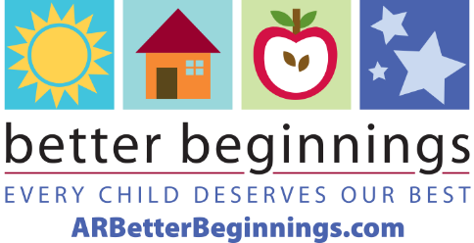
Better Beginnings
2023 Fact Sheet

What is Better Beginnings?
Better Beginnings, a program of the Arkansas Department of Human Services, Division of Child Care and Early Childhood Education, connects Arkansas families with child care providers that help their children experience a safe, happy, healthy childhood in a high-quality learning environment. Better Beginnings also provides education for families and Arkansas child care providers with valuable tools for improving the quality of their programs at every level.

What is the purpose of Better Beginnings?
Better Beginnings is designed to improve the level of quality in child care and early childhood education programs across the state. Better Beginnings distinguishes the quality of each Arkansas child care facility by a star rating system of levels 1 through 6. More stars mean higher quality child care.

How is a program rated for their quality of child care?
Better Beginnings works with providers to train their staff and build a better learning environment. Rating requirements include education and professional development for the director administrator and teachers, assessment of the learning environment, curriculum and activities for learning through play.

How does Better Beginnings assist with finding child care?
To begin the search for child care and early childhood education in a community, families can use the Find Child Care tool on ARBetterBeginnings.com. This tool shows all licensed providers in the state and uses the star-rating system to emphasize Better Beginnings programs.

Who can apply to be a Better Beginnings rated program?
Better Beginnings is available to Arkansas licensed and registered family child care homes, centers and out-of-school time programs.

What type of education do children receive in a Better Beginnings program?
Better Beginnings early childhood educators prepare children for kindergarten with positive experiences, research-based curriculum, and learning through play. Better Beginnings curriculum is based on the early learning and development guidelines of math, science and literacy.

For more information, call 1-501-320-6161 or view these videos.
Early Childhood Education: How children learn through play
https://www.youtube.com/watch?v=0akrbW_Kuhw
Every Child Deserves Our Best: Quality child care looks like early childhood education.
https://www.youtube.com/watch?v=B9UeyYOK7MY

