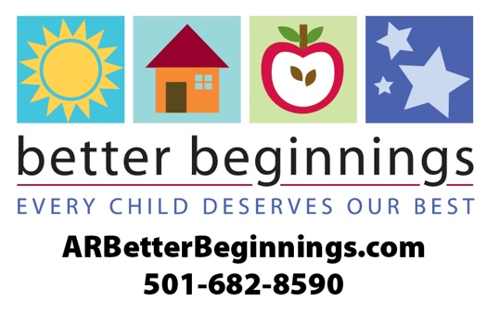
Better Beginnings
2020 Fact Sheet

What is Better Beginnings?
Better Beginnings, a program of the Arkansas Department of Human Services (DHS), connects Arkansas families with information and child care that helps their children experience a safe, happy, healthy childhood. Better Beginnings also gives Arkansas child care providers valuable tools for improving the quality of their programs at every level.
What is the purpose of Better Beginnings?
Better Beginnings is designed to improve the level of quality in child care and early childhood education programs across the state. Better Beginnings distinguishes the quality of each Arkansas child care facility by a 1, 2 and 3-star rating system.
How is a program rated for their quality of child care?
The Better Beginnings staff works with child care and early childhood education providers to train their staff to build a better learning environment. Requirements include administrator and staff training, facility evaluation, curriculum and activities for strengthening families.
How does Better Beginnings assist with finding child care?
To begin the search for child care and early childhood education in a community, families can use the Find Child Care tool on ARBetterBeginnings.com. This tool shows all licensed providers in the state, but uses the star-rating system to emphasize Better Beginnings programs.
Who can apply to be a Better Beginnings rated program?
Better Beginnings is available to family child care homes, centers and school-age programs.
What type of education do children receive in a Better Beginnings program?
Better Beginnings places an emphasis on preparing children for kindergarten and the bright future ahead of them. Better Beginnings provides curriculum based on the early learning and development guidelines of math, science and literacy.

See these Better Beginnings YouTube videos for more information:
The History of Better Beginnings – https://www.youtube.com/watch?v=FmKArv_9UH0
The importance of quality early childhood education and how children learn through play – https://www.youtube.com/watch?v=83icPnRVMDU&t=9s
Discover how the child care and early childhood education landscape in Arkansas affect the current and future economy of our state – https://www.youtube.com/watch?v=8zRjnamEH3E&t=29s

