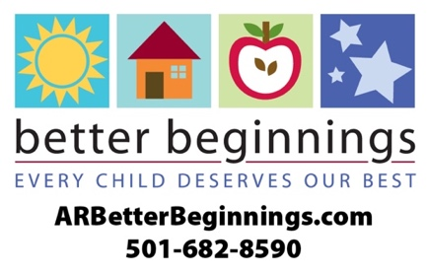

**Letter to Parents**

Change highlighted text, copy and paste onto your letterhead

Date:

Dear Family,

r chilly(Name of program here) has earned a 2-star rating as an Arkansas Better Beginnings program. Better Beginnings is Arkansas’s quality rating improvement system for licensed child care and early childhood education facilities.

Research shows that the early months and years following birth really do matter, that maximum brain development happens during the first five years of life – before children are “officially” in school. Better Beginnings is designed to give children a better beginning to their education.

Better Beginnings provides curriculum based on the early learning and development guidelines: math, science and literacy. Children in our program learn these concepts gradually, through play and experience.

Here are some of the things you may expect as a result of our decision to provide the highest quality child care through Better Beginnings:

* Increased qualifications and training for staff and administrators
* Administrative practices that exceed national standards
* Increased standards for classroom quality
* Daily activities that address learning goals for children
* A written curriculum plan

We invite you to visit **ARBetterBeginnings.com.** Explore theParents & Families tab content to:

* Discover opportunities for combining learning and fun at home in the *Family Resource Library* (also available in Spanish)
* Have an interactive experience with the *Play is Learning Parent Tool*
* Sign up for the monthly newsletter, *The Buzz for Families*, to receive additional resources, tips and learning activities as well as updates for your family.

We are your partners in preparing your child for kindergarten. Our goal is to provide the very best child care and early education as possible.

Sincerely,

(Program Director Signature)