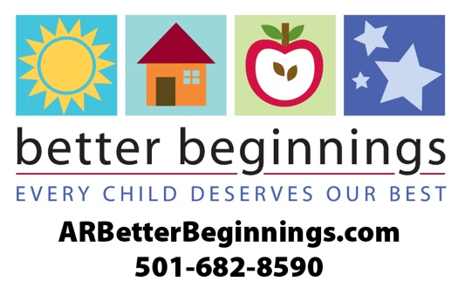

**How to Use Your Star Kit**

Dear 2-star Program Administrator,

Congratulations on taking the next step to provide high quality child care in your community! This Star Kit provides the tools you need to let families, potential clients and your community know about your big accomplishment. Below you will find a list of materials included in this packet and recommendations on how to use each element.

We are excited to get you started on this journey with Better Beginnings. We invite you to follow us on Facebook, Twitter, Pinterest and Instagram. And to stay caught up with Better Beginnings updates, sign up to receive our monthly newsletter, *The Buzz for Providers.*

The Family Resource Library, located under the Parents and Families tab of our website, and under the Spanish tab, at **ARBetterBeginnings.com** provides useful material to engage and educate families. Resource pages can be used as posters in your facility or as handouts.

If you have questions about the materials in your packet or would like to request more information, please contact us at **1-501-682-8590.**

**News Releases**

Let your community know that you are providing the highest quality of child care. Replace the highlighted text with your information, then copy and paste onto your letterhead. Submit the release to your newspaper and any other organization that would like to share your news. You will also find a summer care news release to use when families are looking for summer time care.

**Letter to Families**

Use this letter to tell families about the higher standards they will now see because of your   
2-star rating as a Better Beginnings evaluated program. Replace the highlighted text with your information, then copy and paste onto your letterhead. We encourage you to put this in your children’s backpacks or on your social media channels and website.



**How to Use Your Star Kit**

*continued*

**Fact Sheet**

This will be your quick go-to guide to answer questions about Better Beginnings. Use it when speaking with families, potential clients and your community.

**Logo Sheet**

As a Better Beginnings facility, you have earned the right to use the Better Beginnings logo proudly. You will find a variety of Better Beginnings logos in your star kit. We have included high- and low-resolution images for print and online use. These logos would be great to include on program materials, your website and social media channels.

**Digital Content**

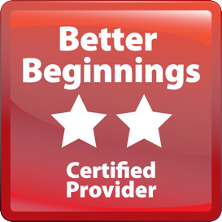Digital content includes this digital button, made specifically for your website to show off your 2-Star status. You will also find a Better Beginnings profile picture and a cover photo art for use on your social channels.



This one-color button can be used for newspaper ads, flyers or for single color premium items such as give-away note pads.