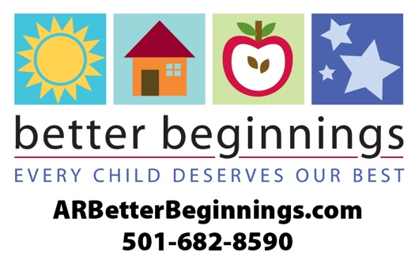

**News Release**

Change highlighted text, copy and paste onto your letterhead

**For more information, contact:**

Program Director Name

Title

Office: (XXX) XXX-XXXX

Email:

**FOR RELEASE: Fill in date**

**(Insert Program) in (city) Earns Quality Rating through Arkansas’s Division of Child Care**

**and Early Childhood Education**

**Fill in city name, ARK., Month, Day, Year** ⎯ (Name of program) has earned a 1-star Better Beginnings rating**. Better Beginnings** is Arkansas’s quality rating improvement system for child care, early education and school-age programs that have gone above and beyond state minimum licensing requirements. Better Beginnings distinguishes the quality of each child care facility by a 1, 2 and 3-star rating system.

“Research shows that the early months and years following birth really do matter, that maximum brain development happens during the first five years of life – before children are ‘officially’ in school. We want children to have a better beginning to their education,” said Tonya Williams, Director, Division of Child Care and Early Childhood Education**.**

Better Beginnings provides curriculum based on the early learning and development guidelines: math, science and literacy. Through a high-quality learning environment, children develop social and academic skills that lead to school success.

Better Beginnings connects Arkansas families with information and child care that help children experience a safe, happy and healthy childhood. For more information on Better Beginnings visit **ARBetterBeginnings.com** or call **1-501-682-8590.**

# # #